 | Term 1 |  | Term 2 | Term 3 | Term 4 | Term 5 | Term 6
Topic: | Ever changing Britain. |  |  | 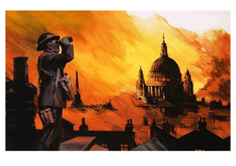  WW2: Bunkers, bombs and the Blitz. |  | 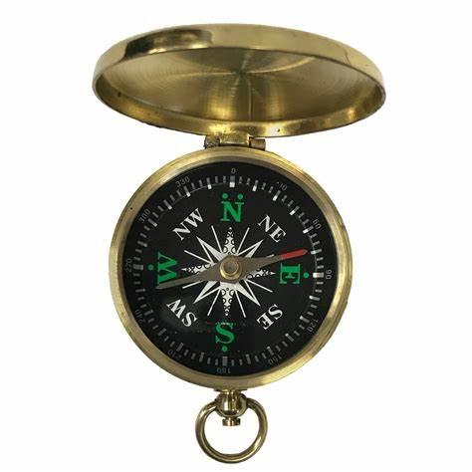  Extreme Earth.
English: | Writing persuasive letters to Boris Johnson. writing to persuade  Persuasive speeches writing to persuade |  | Fact pages(Anglo Saxons)- double page spread writing to inform  Newspaper reports (Anglo Saxons - discussion text)- non chronological report writing to discuss | Instructions- how to stay safe in an air raid. writing to inform.  Poetry- flight poetry and the unsung heroes (words over pictures) Writing to entertain | Narrative- evacuee story (Writing to entertain)  Diary entry writing to inform / entertain. | Leaflets- types of rivers and canals writing to inform.  Poetry- life is a river Writing to entertain | Instructions- living on Eal’s Island writing to inform.  Thriller narrative- the sequel to Floodland (find a compass and use directions in story) Writing to entertain
VGP focus: | Modal verbs  De: De sentences  If,if,if, then.  Relative clauses  Statistics  3 ED adjectives |  | 3 bad – (dash) question.  If,if,if, then.  Relative clauses  parenthesis  Past continuous, past perfect, past perfect continuous (tenses) | With a(n) action, more action  Personification of weather  Double -ly ending  Present continuous, present perfect, present perfect continuous (tenses) | 2 pairs sentences  Ing, ed sentences  Emotion, comma  FANBOYS  Perfect forms of verbs | Imagine 3 examples.  metaphor, onomatopia  repetition, rhyme, alliteration, personification, similies. | The more, the more  Verb, person  Ad, same ad  Future continuous, future perfect, future perfect continuous.
Topic texts: | Boy at the back of the Class.  Martin Luther King’s speech  The Journey by Francesca Sanna (refugee picture book) |  | Freedom for Bron, the boy who saved a kingdom by N.S Blackman  Poetry- A poem home from Mars. | Goodnight Mr Tom  Tail- End Charlie by Mick Manning (comic style picture book) |  | Floodland by Marcus Sedgwick (thriller story) | The River by Allesandra Sanna (geography and setting- picture book))
Geography : | Life in Syria (physical and human features)  Locate and describe features of countries.  My local area |  |  |  |  | Region of the UK- London (centre and outskirt- rich and poor)- Looking at Rivers that pass through UK  Compared to Switzerland – Look at River Rhone and the Alps  Locate countries and rivers on a map.  Use compass directions (Term 6- narrative)  (MFL link: French speaking country).
History: |  |  | Anglo Saxons- Britain’s settlement by Anglo- Saxon and Scots. | WW2 – a significant turning point in British History.  London in the Blitz. | Irena Persak (alternative WW2 perspective: Polish deportation)
Maths: | Place value (3 weeks)  Addition and subtraction (2 weeks) |  | Addition and subtraction (2 weeks)  Perimeter and area (2 weeks)  Geometry: shape (2 weeks) | Multiplication and division (6 weeks) | Fractions (6 weeks) | Decimals (3 weeks)  Decimals and percentages (2 weeks)  Statistics (2 weeks) | Geometry: position and direction (2 weeks)  Converting units (2 weeks)
PSHE: | Identify and equality |  | Money and economics | Feelings and friendships | Saftey and risk  Growth Mindset | Rights and responsibilities. | Health, relationships, sex, education (HRSE)
Computing: | E- Saftey | Multimedia: news report on the Anglo Saxons. |  | Programming | Data handling  Networks and the internet | App design
Science:  Stem.org.uk | Earth and Space  STEM: is anybody out there? (martian soil)  STEM: eggnaut (gravity experiment) |  | Forces  STEM: air resistance balloon buggy’s  STEM: aircraft forces (red arrows) | Materials | Separating mixtures  STEM: growing crystals.  STEM: suspended ice | Types of change  STEM: plastic from milk (irreversible change)  STEM: insulating ice- reversible changes) | Life Cycles
Art and DT: | Banksy: graffiti writing- mono printing |  | Bayeux tapestry inspired sewing. | Blitz scene- silhouette of landscape- chalk/ charcoal | WW2 day: design and create Anderson shelter models (link to materials)  Fashion- make do and mend | Trompe O’Leil inspired perspective drawings of London street | Mechanisms.
Trips: | Literature Festival. |  | Anglo Saxon day (DT day and dress up) | WW2 day.  Swindon GWR museum, air raid and evacuee experience. |  | Pond dipping | Gloucester waterways museum.

